Task 2: Fibonacci Sequence

The Fibonacci Sequence is the series of numbers:

0, 1, 1, 2, 3, 5, 8, 13, 21, 34, ...

The next number is found by adding up the two numbers before it.

**Working Procedure:**

When I run the software at first it display a message for asking insert a number. In this software have a Fib() method and it have an integer parameter. After taking input it go to Fib() method with this number and then find the Fibonacci sequence number. After finding the number it shows the number in the display.

**Algorithm:**

At first take a variable. Then convert string input to number. Then create a function that name is Fib() and it has integer parameter. Then call this function. In this function I calculate and get the Fibonacci sequence number.

**Exception Handling:**

In this program I use try catch for error handling. If the program have any problem or if the user insert any string value then it show an error message.

**Code:**

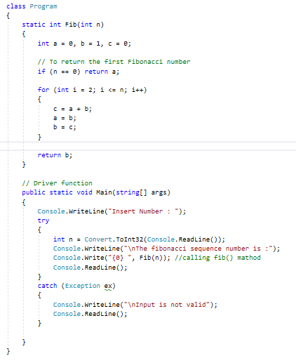

**Output:**

